# Chapter 1 Introduction

1. **Digital image** : A two-dimensional function f(x,y) where x and y are spatial coordinates,and f at any pair of coordinates has a specific intensity value.

**Pixel/pel :** finite element of a digital image, which has a particular location and values.

1. **Digital Image Processing : Image acquisition, Image filterng and enhancement (subjective), Image restoration** (to improve the quality of a degraded image,the image reconstruction is to creating an image from incomplete data), **Color image processing, Wavelets and multiresolution processing, Compression, Morphological processing, Segmentation, Representation & description, Object recognition.**
2. **Image Processing System :** sensoring, digitizer, specialized hardware, computer, software, mass storage, image display, hardcopy, network.
3. **medical image :** X-ray Images, CT (Computed Tomography) Images, MRI (Magnetic Resonance Imaging) Images, Ultrasound Images, NMI (Nuclear Medicine Images)Images.

# Chapter 2 Digital Image Fundamentals

1. Structure of the Human Eye

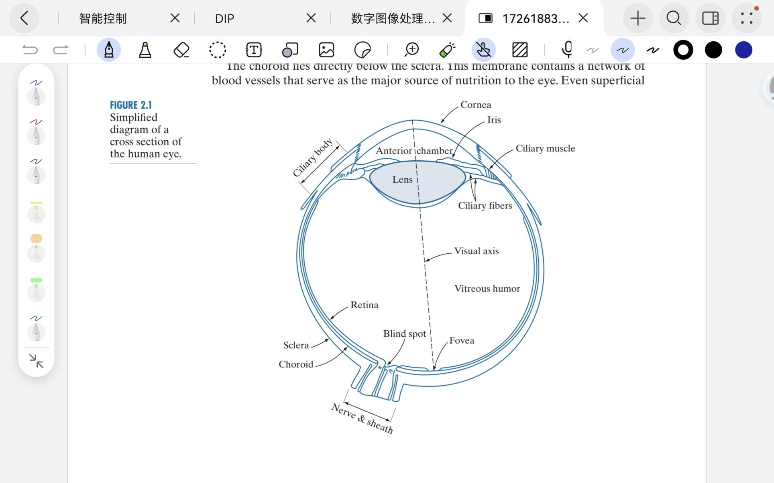

Cones and rods are the discrete light receptors on the retina surface.

Cones (6 to 7million) in the central portion(fovea), are highly sensitive to color (65% red, 33% green, 2% blue(most sensitive)). Humans can resolve fine details with them. Cone vision is called photopic or bright-light vision.

Rods (75 to 150 milion) are distributed on the larger area and are sensitive to low levels of illumination.They give a general, overall picture of the field of view. scotopic or dim-light vision.

1. brightness adaption: visual system cannot operate over such a range simulaneously,it accomplishes this large variation(1010) by **changing** its overall **sensitivity**.
2. visible (color) spectrum: 0.43 μm (violet) to 0.79 μm (red).
3. **Monochromatic/achromatic** : void of color; The only attribute is intensity (gray level measure) or amount.monochromatic images as gray-scale images.

**gray scale** : The range of measured values of monochromatic light from black to white.

**gray level** : the intensity value of a pixel in a image into a digital form.

1. **Chromatic (color) light** :

three basic quantitie:

**Radiance** : total amount of energy that flows from the light source. W,watt.

**Luminance** : the amount of energy an observer perceives from a light source. lm,lumens.

**Brightness** : a subjective descriptor of light perception , is impossible to measure.

1. **Sampling and quantization** : to convert the continuous sensed data into digital form.

**Sampling** : digitizing the coordinate values. 

**Quantization** : digitizing the amplitude values. 

1. Bits required to store a digitized image : 

M,N : positive integer ; discrete gray-level : (**k-bit image**)

1. **Spatial / image resolution** : the number of pixels per unit of an image/line pairs per unit distance. A measure of the smallest discernible detail in an image.

**Gray / intensity resolution** : smallest discernible change in intensity level.

1. Interpolation : the process of using known data to estimate values at unknown locations.
2. **4-neighbors of p** : N4 (p) = (x+1, y), (x-1, y), (x, y+1), (x, y-1)

Diagonal neighbors of p : ND(p) = (x+1, y+1), (x+1, y-1), (x-1,y+1), (x-1, y-1)

**8-neighbors of p** : N8 (p) = N4 (p)∪ND(p)

1. V = {1}

**4-adjacency** : coordinate(q)∈N4(p) and value(q)∈V

**8-adjacency** : coordinate(q)∈N8(p) and value(q)∈V

**m-adjacency** : coordinate(q)∈N4(p) or [ ND(p) - N4(p)∩N4(q) ] and value(q)∈V

1. 



**Dm(p,q)** is defined as the shortest m-path between the points.

# Chapter 3 Intensity Transformations and Spatial Filtering

1. spatial domain techniques operate **directly** on the pixels of an image. g(x, y) = T[ f (x, y) ]
2. **Basic Intensity Transformation Function**:Linear (negative and identity), Logarithmic (log and inverse-log), power-law (nth power and nth root)

negative : 

log : c is to control the scaling of the output image.

Power-law (Gamma) : 

**Piecewise-Linear** : contrast stretching, Intensity-level slicing,bit-plane slicing; it allows for selective enhancement and control over different regions of the intensity range.

1. **Normalized histogram** : ,is an estimate of the probability of occurrence of intensity level rk in an image. The sum of all equal to 1.
2. **Image : gray histogram = many to one ( n : 1 )**
3. **Histogram Equalization** : to enhance contrast, to produce an image with a uniform histogram of intensity value. by redistributing the gray values of the pixels in the image, make the gray histogram of the output image distribute as evenly as possible. Weighted average.
4. A spatial filter consist of (1) a neighborhood,(typically a small rectangle),and (2) a predefined operation that is performed on the image pixels encompassed by the neighborhood. Weighted sum.
5. **Smoothing spatial filters** are used for **blurring** and for **noise reduction**.

Averaging filter/smoothing linear filter : reduction of irrelevant details (small object). by replacing the value of every pixel in an image by the average of the intensity levels in the neighborhood defined by the filter mask.undesirable blur edges.

Order-Statistic (Nonlinear) Filter:

Median filter : processing random noise (impulse noise,salt-and-pepper noise). ordering/ranking the pixels contained in the image area encompassed by the filter, and then replacing the value of the center pixel with the value determined by the ranking result.

Max filter : finding brightest points.

1. **Sharpening spatial filter** : **highlight transitions** in intensity, **enhances** edges and other discontinuities and deemphasizes areas with slowly varying intensity . Defining and implementing operators for sharpening by digital differentiation.

One-dimensional : 

Second-dimensional : 

Laplacian (second derivative) : 

# Chapter 5 image restoration and reconstruction

1. image **enhancement** is **subjective**, while image **restoration** is **objective**.
2. Restoration is oriented toward modeling the degradation and applying the inverse process in order to recover the original image.
3. Restoration in the presence of noise only - spatial filtering

Spatial domain : g(x, y) = f(x, y) + n(x, y)

frequency domain : N(u, v) = N(u, v) + N(u, v)

1. Common noise : 5.2.2

Gaussian noise : a kind of noise whose probability density function follows a Gaussian distribution

white noise : has a power spectral density that is uniformly distributed across the entire frequency domain

impulse noise : a noise that appears in discrete pulses with relatively high amplitudes and short durations. E.g.salt-and-pepper noise.

1. Mean filter:

Arithmetic mean filter :  Gaussian noise

Geometric mean filter : 

Harmonic mean filter :  salt noise(1),Gaussian noise

Contraharmonic mean filter : 

**Q > 0 : pepper noise(0); Q < 0 : salt noise(1)**

**Q = 0 : Arithmetic mean filter; Q = -1 : Harmonic mean filter**

1. Order-statistic filter:

Median filter :  bipolar and unipolar impulse noise.

Max filter :  pepper noise, finding the brightest points

Min filter :  salt noise, finding the darkest points

Midpoint filter : impulse noise,random noise.

Alpha-trimmed mean filter : 

Delete the d/2 lowest and the d/2 highest intensity values of g(s,t) in the neighborhood.

d = 0 : Arithmetic mean filter; d = mn - 1 : Median filter; other d : multiple noise

1. Adaptive median filter :

Advantage : can handle impulse noise with probabilities larger than the noise which the median filter performs well about.Another advantage is that the adaptive median filter seeks to preserve detail while smoothing nonimpulse noise.

Difference : it changes (increase) the size of Sxy during filter operation,depending on some conditions.

Psudo-code :



# Chapter 6 Color Image Processing

1. full color : acquired with a full-color sensor, pseudocolor : assigning a color to a particular monochrome intensity or range of intensities.
2. Designated the **three primary colors** : **blue** = 435.8nm, **green** = 546.1nm,**red** =700nm. **Not** mean that these three fixed RFB components acting alone can generate all spectrum colors. Mix these in the right intensities produces **white** light.
3. **Secondary colors** : **magenta** (red plus blue), **cyan** (green plus blue), **yellow** (red plus green).
4. **Primary colors of pigments** or colorants : subtracts or absorbs a primary color of light and reflects or transmits the other two. The primary colors of pigments are magenta, cyan, yellow, the secondary colors are red, green, blue.Mix these in the right intensities produces **black** light.
5. Distinguish one color from another : brightness, hue, saturation.

**Brightness** : embodies the achromatic **notion of intensity** (intensity is a most useful descriptor of monochromatic images).

**Hue** : an attribute associated with the dominant **wavelength in a mixture** of light waves. Hue represents dominant color as perceived by an observer.

**Saturation** : the relative purity or the amount of **white light mixed** with a hue. The pure spectrum colors are fully saturated. The degree of saturation being inversely proportional to the amount of white light added.

Chromaticity : hue and saturation.

1. Tristimulus coefficients : 
2. Color model (color space, color system) : to facilitate the specification of color in some standard,generally accepted way.
3. RGB color model:

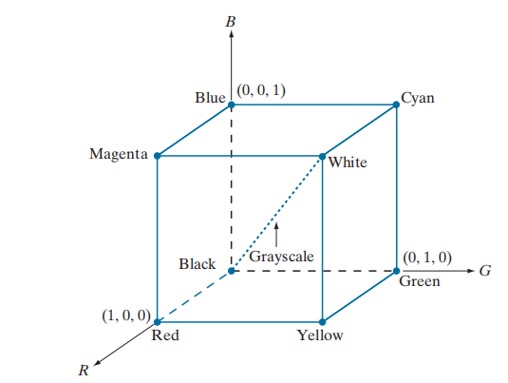

1. Pixel depth : the number of bits used to present each pixel in RGB space.
2. Full-color image : **24-bit RGB image** (each of the r,g,b images is an 8-bit image), the total number of colors is (28)3=16777216.
3. CMY and CMYK color model :

C,m,y are the Primary colors of pigments, 

Combining these colors for printing produces a muddy-looking black, to produce true black, added the fourth color, black.

1. **HSI** color model : an ideal tool for developing image processing algorithms based on color descriptions that **natural and intuitive to humans**.
2. Converting colors from RGB to HSI



1. Converting colors from HSI to RGB



1. Pseudocolor (false color) : assigning colors to **gray values** based on a specified criterion. The principal use of pseudocolor is for human **visualization and interpretation** of gray-scale events in an image or sequence of image.
2. Intensity slicing : slice the image (as a 3-D function) function into two levels. Different color is assigned to each side of intersection.
3. Full-color image processing : I.process each component image individually and them form a composite processed color image from the individually processed component. II.work with color pixels (as vectors) directly.
4. Color transformations :

Color complement : the hues directly opposite one another on the color circle.

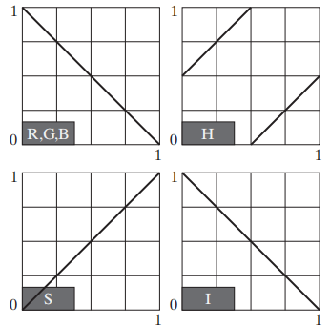





Highlighting : I.display the color of interest so that they stand out from the background. II.use the region defined by the colors as a mask for further processing.

Color slicing : map the colors **outside** some range of interest to a **nonprominent neutral** color.

Cube : 

Sphere : 

**Histogram** processing : histogram equalize the components of a color image independently will result in erroneous color. A method is to spread the color **intensities** uniformly, leaving the colors themselves (e.g. hues) unchanged.

1. Color image **smoothing** : **RGB** : the color of each pixel is the **average** color of the pixels in the neighborhood. **HSI** : only smoothing the **intensity** component (leaving the hue and saturation components unmodified).
2. Color image **sharpening** : **RGB** : compute the **Laplacian** of a full-color image by computing the Laplacian of **each** component image **separately.**
3. Image segmentation based on color : **HSI** : **saturation** is used as a masking image in order to isolate further regions of interest in the **hue** image (Intensity is less used). **RGB** : to classify **each** **RGB pixel** in a given image as having a color in the specified range or not.